
Lesson 5 Teacher's Key
001 Game Creator
INSTRUCTOR ONLY - do not distribute to students

Level 1 - Complete Worked Solution
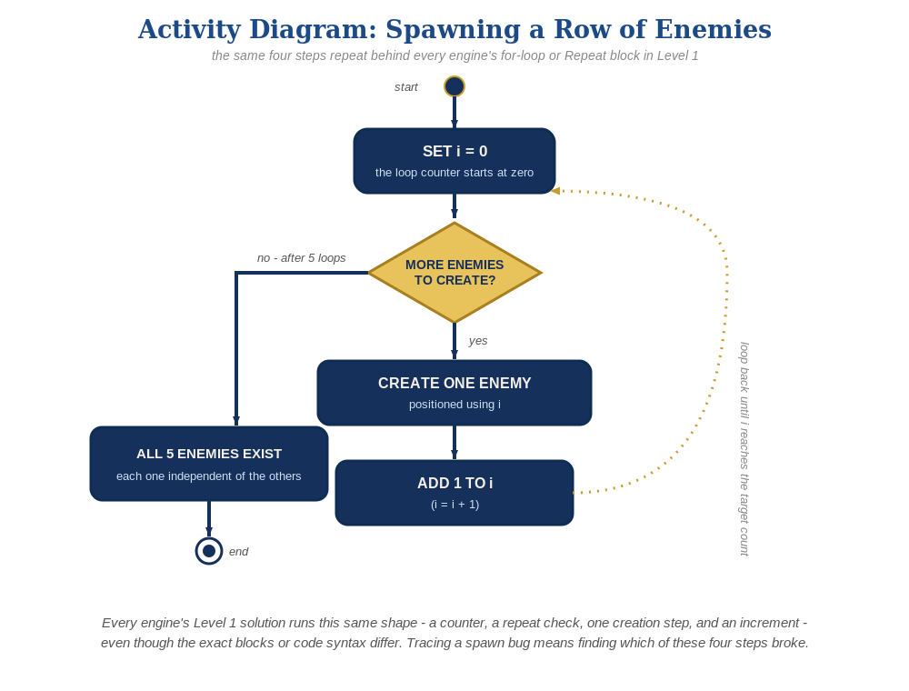
The spawn loop, in general - the same counter, repeat check, creation step, and increment behind Level 1 in every engine, whatever the exact blocks or syntax look like.
No loop and no new scripting at all - just more copies of the same Actor Template placed on the Map. This is the one engine this week where "multiple enemies" is a placement task, not a code task:
Copy/paste the enemy Actor 4 more times on the Map, spaced out in a row with at least a full enemy-width of gap between each one.
Each copy automatically keeps its own working "Collided with actor" Trigger script from Lesson 4:
enemy Actor Trigger: Collided with actor ->
Actor – Destroy/Revive Actor(relate, Destroy)
Actor – Destroy/Revive Actor(this, Destroy)

Level 2 - Complete Worked Solution
Every placed copy of an Actor Template runs its own independent copy of that Template's Triggers - this is the same underlying idea as "every instance behaves independently" in every other engine this course uses, just expressed through placement instead of a spawn loop. No extra scripting is needed for Level 2.

Level 3 - All Worked Solutions
Every stretch-goal idea from the handout, fully worked - not just one. Useful for validating each idea actually works before class, and as a ready reference no matter which one a student ends up picking.

Sound: already works
The "Play Sound" event in the enemy's "Collided with actor" script runs independently for every copy that gets hit - no changes needed.

Visual: row variety
Select an individual pasted copy and adjust its own Tint (Actor > Graphics Options > Tint, per-instance override, not the Template) for a couple of enemies to look slightly different from the rest. #C81937 is a deep crimson red and #E66482 is a lighter dusty rose/pink - the same two shades used across this course's other engines this lesson, just as hex codes here instead of RGB numbers.

Structure: no change needed
The same "everything about being hit lives on the enemy Actor's own Trigger" structure from Lesson 4 already scales to any number of copies for free - there's nothing new to organize this week.

Complete Level 3 solution (all 2 goals combined)
The enemy Actor Template's Trigger script, unchanged from Lesson 4, plus per-instance Tint variation on a couple of the pasted copies:
enemy Actor Template Trigger: Collided with actor ->
Play Sound(sfx_hit.wav)
Actor – Destroy/Revive Actor(relate, Destroy)
Actor – Destroy/Revive Actor(this, Destroy)
(plus: 2 of the 5 pasted copies given a per-instance Tint of #C81937 - deep crimson red - and the other 3 left default or set to #E66482 - lighter dusty rose/pink)

